**Magnitude comparator**

**Lab no #08**

** Fall 2019**

**Fall 2021**

**CSE202L Digital logic and computer design**

Submitted by: **Ashfaq Ahmad**

Registration No. : **19PWCSE1795**

Class Section: **B**

“On my honor, as student of University of Engineering and Technology, I have neither given nor received unauthorized assistance on this academic work.”

Student Signature: ______________

Submitted to:

**Engr. Abdullah hameed**

January 31, 2021

**Department of Computer Systems Engineering**

**University of Engineering and Technology, Peshawar**

**Objective:**

* Realization of 1-bit comparator using logic gates.
* Realization and implementation of 2-bit comparator using logic gates on breadboard.
* Implementation of 4-bit magnitude comparator on breadboard using IC 7485.

**Components Required:**

* Breadboard.
* IC Type 7486 Quadruple 2-input XOR gates.
* IC Type 7408 Quadruple 2-input AND gates.
* IC Type 7400 Quadruple 2-input NAND gates.
* IC Type 7410 Triple 3-input NAND gates.
* IC Type 74L85 4-bit magnitude comparator.
* Switches for inputs and
* LED displays for outputs.

**Theory:**

Magnitude comparator is a combinational logic circuit that compares between two binary numbers A and B and determines their relative magnitudes. The output of the circuit is specified by three binary variables whether: A>B, A=B or A<B

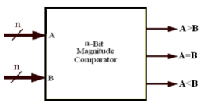

**1-bit Magnitude Comparator:**

A comparator used to compare two 1-bit binary numbers. It has two binary inputs A, B and three binary outputs: greater than, equal and less than relations. Figure 2 below shows the block diagram and truth table of a 1-bit magnitude comparator.

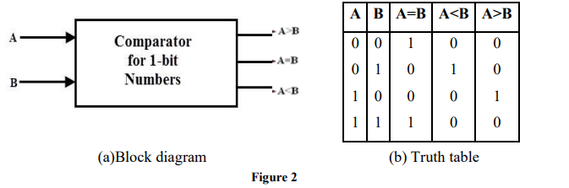

The Boolean functions describing the 1-bit magnitude comparator according to the truth table are:

(A > B) = AB' (A = B) = A'B' + AB=(A XNOR B) (A < B ) = A'B

The logic diagram for 1-bit binary comparator implemented by XOR and basic logic gates is shown below in figure 3.

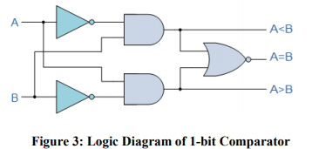

So we conclude that digital comparators actually use Exclusive-NOR gates within their design for comparing their respective pairs of bits.

**Note: sir due to insufficient components I performed this lab in a proteus software.**

**Real life Picture of 1-bit Magnitude comparator:**

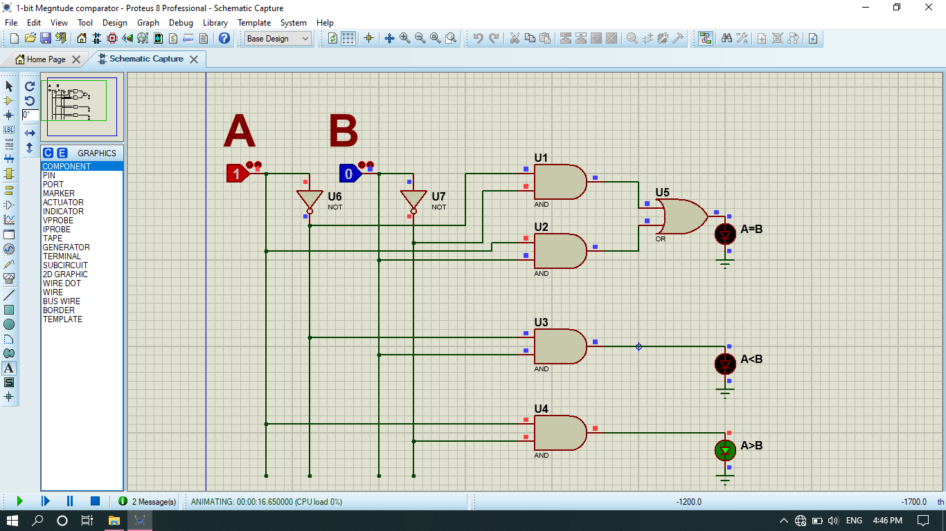

**2-bit Magnitude Comparator**:

A comparator used to compare two 2-bit numbers. It has 4 binary inputs (number A: A1A0, number B: B1B0) and 3 binary outputs: greater than, equal and less than relations. Figure 4 below shows the block diagram and truth table of a 2-bit magnitude comparator.

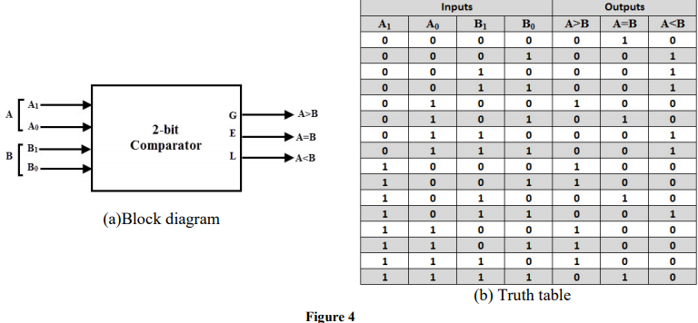

Using key-map, the simplified Boolean function for the outputs A>B, A=B and A<B is shown below:

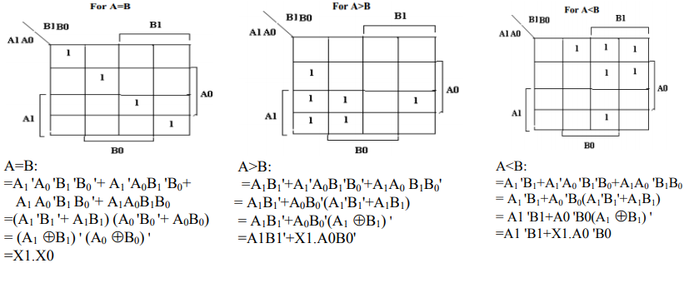

Based on the simplified Boolean functions for the three outputs A>B, A=B and A<B, the logic diagram of the 2-bit magnitude comparator is shown below:

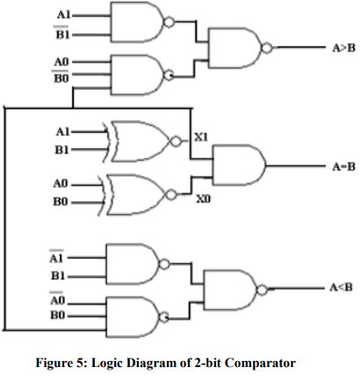

**Real life picture of 2-bit magnitude comparator:**

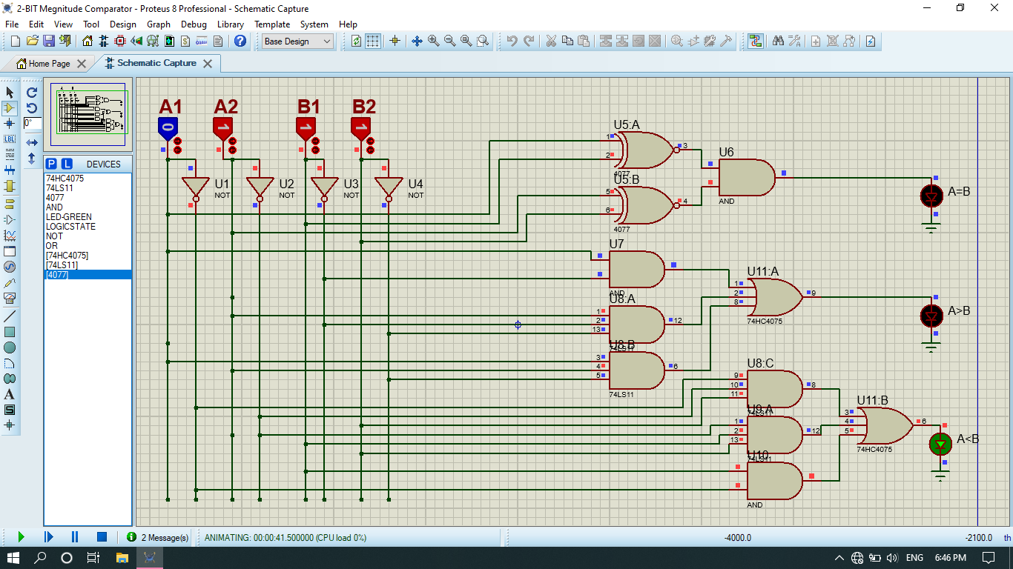

**4-bit Magnitude Comparator:**

A comparator used to compare two 4-bit words. The two 4-bit numbers are word A: A3A2A1A0, and word B: B3 B2B1B0) So the circuit has 8 inputs and 3 binary outputs: A>B, A=B and A<B.

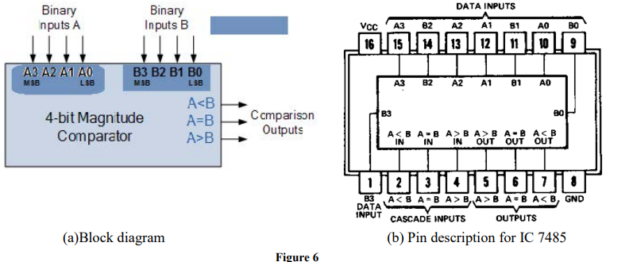

Figure 6 shows the block diagram and pin configuration of IC 7485 for 4-bit magnitude comparator. Three inputs are available for cascading comparators. This comparator generates an output of 1 at one of three comparison outputs such that:

* If word A is bigger than word B; A>B output (pin 5) is “1”,
* If word A is smaller than word B; A<B output (pin 7) is “1”,
* If word A is equal to word B; A=B output (pin 6) is “1”.

This IC can be used to compare two 4-bit binary words by grounding the cascade inputs A<B (pin 2) and A>B(pin 4) and connecting the cascade input A=B (pin 3) to Vcc.

**How does a 4-bit comparator work?**

**Equality:**

Word A equal word B if: A3=B3, A2=B2, A1=B1, A0=B0.

**Inequality:**

* If A3 = 1 and B3 = 0, then A is greater than B (A>B). Or
* If A3 and B3 are equal, and if A2 = 1 and B2 = 0, then A > B. Or
* If A3 and B3 are equal & A2 and B2 are equal, and if A1 = 1, and B1 = 0, then A>B. Or
* If A3 and B3 are equal, A2 and B2 are equal and A1 and B1 are equal, and if A0 = 1 and B0 = 0,then A > B.
* If A3 = 0 and B3 = 1, then A is less than B (A<B). Or
* If A3 and B3 are equal, and if A2 = 0 and B2 = 1, then A < B. Or
* If A3 and B3 are equal & A2 and B2 are equal, and if A1 = 0, and B1 = 1, then A<B. Or
* If A3 and B3 are equal, A2 and B2 are equal and A1 and B1 are equal, and if A0 = 0 and B0 = 1,then A < B.

**Part A: Lab Tasks**

**Procedure:**

1. Check all the components for their working.
2. Insert the appropriate ICs into the IC base.
3. Make connections as shown in the circuit diagram in figure 5.
4. Verify the Truth Table and observe the outputs.
5. Repeat the same steps but for the circuit diagram in figure 6 and apply

inputs in the following table.

Real life pic:

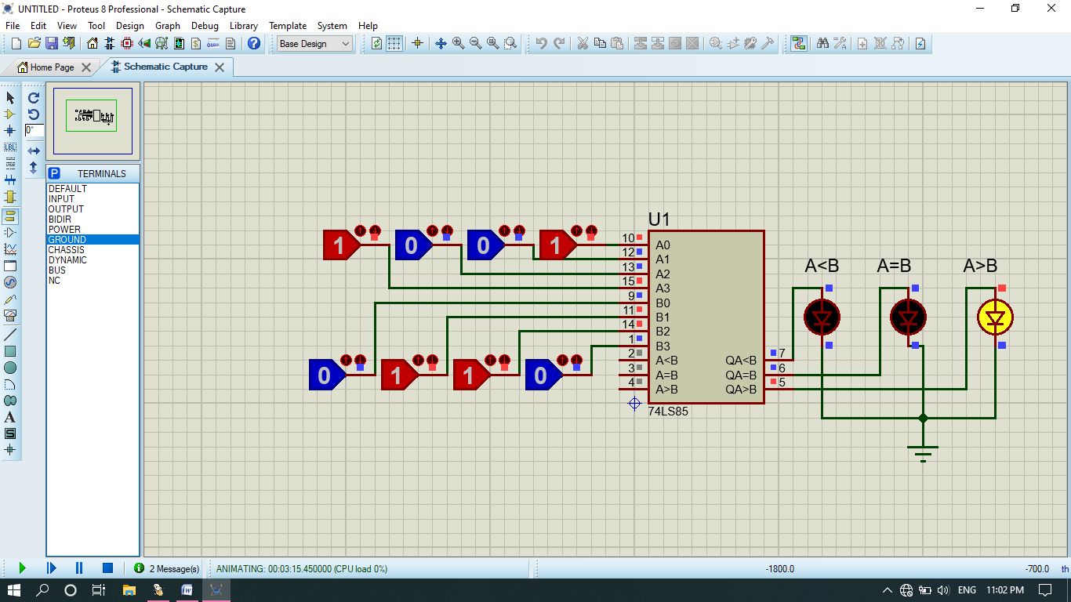

Record the outputs for the given values of A and B

|  |  |  |
| --- | --- | --- |
| A | B | Output |
| 1001 | 0110 | A>B |
| 1100 | 1110 | A<B |
| 0011 | 0101 | A<B |
| 0101 | 0101 | A=B |

**Conclusions:** Magnitude comparator is studied.

**Part B: Post Lab Task (Bonus, worth 5%):**

1. Design an 8-bit comparator using two chips of IC 7485. The connections are given below.
2. Verify the given truth table

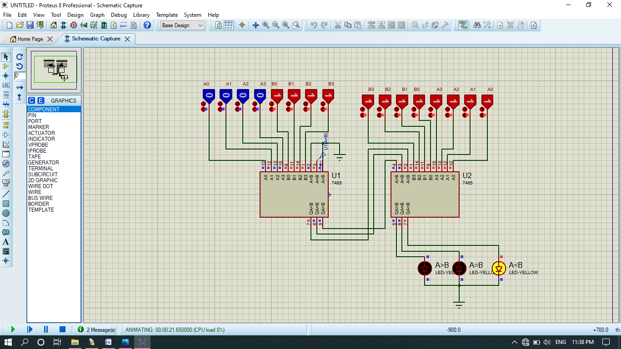

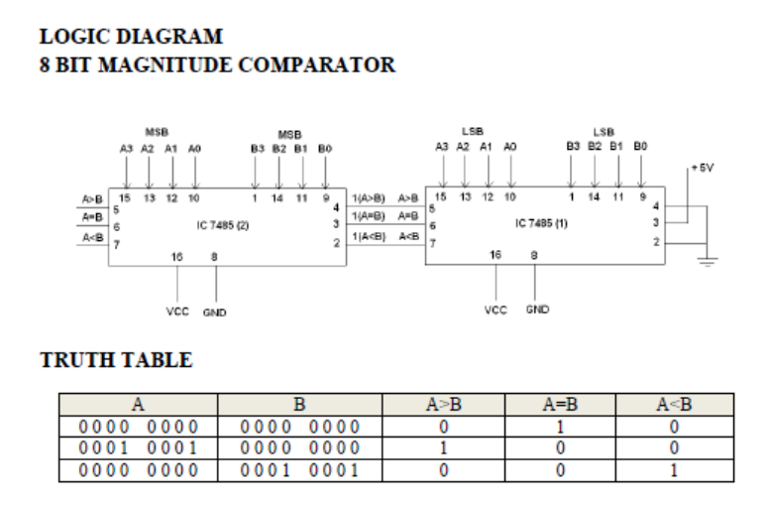

Truth table verified.

***THE END***